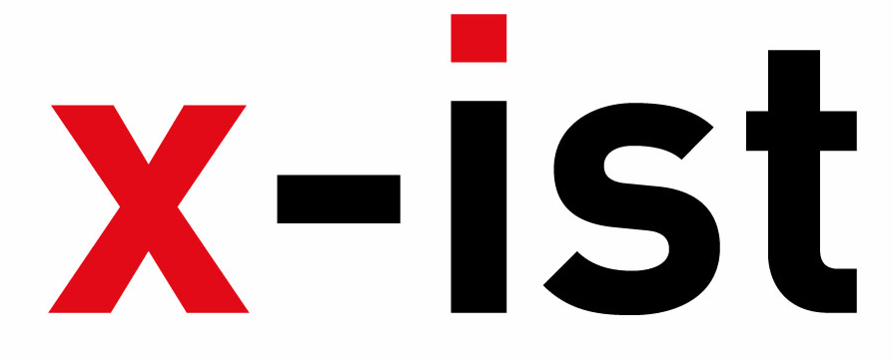 | Abdi İpekçi Caddesi Kaşıkçıoğlu Apt. No:42 D:2 34365 Nişantaşı İstanbul  www.artxist.com  info@artxist.com  T. +90 212 291 77 84 F. +90 212 343 69 35 | PRESS RELEASE

“x-ist @ Art Basel Hong Kong 2013”

x-ist takes place in Art Basel in Hong Kong 2013 between May 23-26, 2013 with the works of two Turkish artists, Nuri Kuzucan and Ceren Oykut, both of who focus on the city in their work. The established painter Nuri Kuzucan paints his impressions of the city concentrating on urban architecture, whereas Ceren Oykut, the drawer dissects and re-combines different elements and stories within the city in her giant works that resemble miniatures.

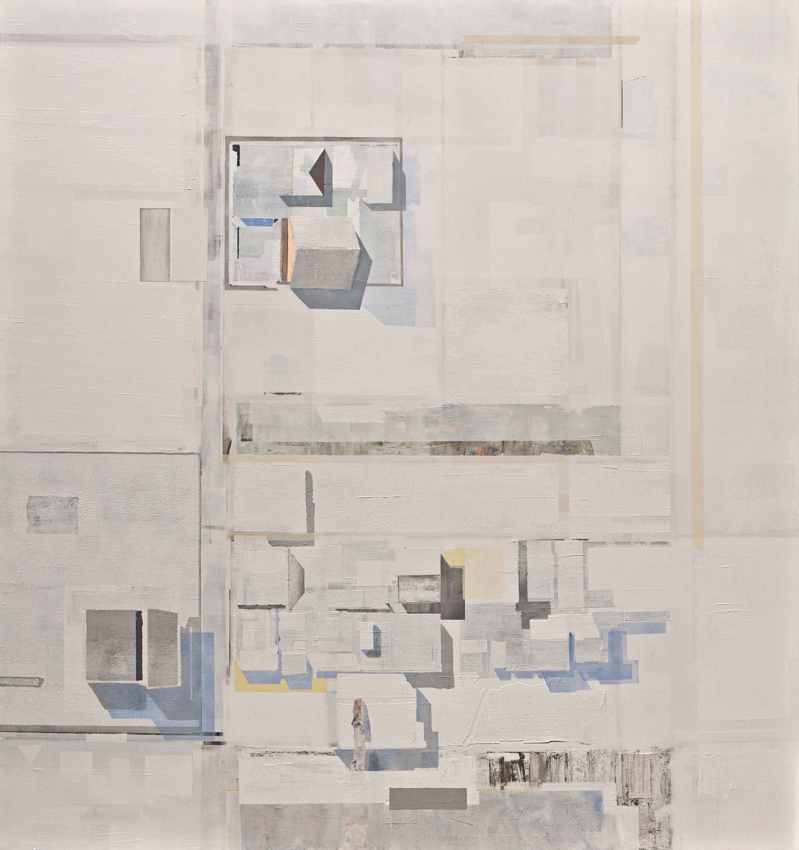

Nuri Kuzucan, “Plan II”, Acrylic on canvas, 200 x 190 cm, 2012

Nuri Kuzucan (1971) has previously produced works with a perspective that break the boundaries of man-made urban landscapes. Through his own images of the city, he reshaped our vision of the era he witnessed, the city and conceptual modernism to make it all more bearable for us. The questing layers and the reflections that stand out in his paintings, which examine the city, urbanization and modernism, were results of his desire to investigate the hidden story behind landscapes and the power the city contains. The storiessometimes play out the scene of the crime, congestion and demolition and attimes act as a justification for urban culture. In April 2013, Kuzucan opened his new solo show at Edouard Malingue Gallery (Hong Kong) which will continue until May 18th.

Ceren Oykut (1978), one of the most exquisite drawers in Turkey, brings together painting and cartoon in her work where she combines her personal memories with everyday scenes from Turkey (specifically Istanbul). These meticulously drawn black and white miniatures reflect her subconscious while reconstructing social events and contain symbols that refer to the urban life as well as the artist herself. Her work have been shown in many exhibitions in Turkey, Germany, Italy, Slovenia, France, Poland, Austria, Ireland, Belgium, Egypt including Lyon Biennale (2009), Istanbul Biennale (2007) and Venice Biennale (2009).

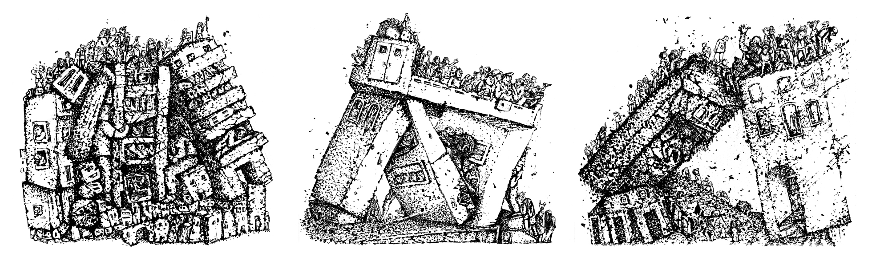

Ceren Oykut, “Condominium I-II-III”, Ink on paper, 58 x 65.5 cm (each), 2012

Artist Biographies

Nuri Kuzucan
Zara, 1971

Kuzucan completed his masters degree at the Mimar Sinan University, Social Sciences Institute after he graduated from Mimar Sinan University, Fine Arts Faculty. Between 1998-2000 he was a lecturer at Yeditepe University, Fine Arts Faculty (Istanbul). He had five solo shows at x-ist: “Open Place” (2004), “Traffic” (2006), “Are You Happy?” (2008), “Plan” (2010) and “Interior & Exterior” (2011). The artist participated in Contemporary Istanbul’07, 08, 09 & 10, Art Fair Cologne’06 (Germany, 2006), SCOPE Basel 2010, 2011 and 2012, ART HK’11 (Hong Kong International Art Fair), Art Dubai 2011, Art Beat 2011 and VIP Art Fair 2012 fairs. His works were displayed at the group exhibits “Turkish Art New and Superb” that took place at Tanas, Berlin in 2012. Nuri Kuzucan is featured in the book “Unleashed: Contemporary Art From Turkey” first published in 2010.

Ceren Oykut
İstanbul, 1978

After graduating from Mimar Sinan University, Fine Arts Faculty, Painting Department in 2002, Ceren Oykut had her first solo show in 2003 “Drawing Exhibition” in Kultur Köln 30, Germany. Oykut’s other solo shows are: “Utopia” (Karaburun Festival, İzmir, 2005), "City Can" (Under Construction Contemporary Art Space, Maltepe, İstanbul, 2006), "City Can" (Under Construction Contemporary Art Space - Kuştepe Branch, Kuştepe, İstanbul, 2006), "Musical Drawings" (Karaburun Festival, İzmir, 2006), "Lost Passport” (Kibla, Maribor, Slovenia, 2008), "Original / No Subtitles" (artSümer, İstanbul, 2010), “With Bells On" (artSümer, İstanbul, 2011). Among the national and international exhibitions, biennials and fairs she participated in are: "Postcards from Stockholm / Istanbul" (Botkyrka Konsthall, Stockholm, Sweden, 2006), "Hafriyat Group Exhibition" (Hafriyat Karaköy, 2007), "Save As.. Contemporary Art From Turkey" (Triennale Bovisa, Milano, İtaly, 2008), "Tracing" (Kasa Gallery, 2009), "Istanbul Traverseé" (Palais Des Beaux Arts De Lille, France, 2009), “Reciprocal Visit” (DEPO, İstanbul, 2009), 10th Istanbul Biennial ("2+1", santralistanbul, 2007), Lyon Biennial 2009 ("La Spectacle du Quotidien", Musee d’Art Contemporain de Lyon, France) and SCOPE Basel 2012 art fair. Invited by Lille 3000 for "I Dream But.." and "İstanbul Traverseé" exhibitions she attended a residency program in France. Oykut also contributes to several periodic publications such as Radikal Kitap, Bant Magazine. Ceren Oykut is featured in the book “Unleashed: Contemporary Art From Turkey” first published in 2010.

